Cascade Shooting Facilities
Ravensdale, Washington
Affiliated with the
National Rifle Association and Civilian Marksmanship Program

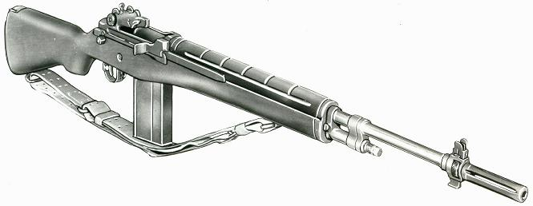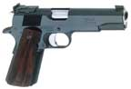

2020 November, Service Pistol-Service Rifle

Name | Pistol |  | Rifle |  | Aggregate
John Benjamin | 361-x |  | 579-17x | 2nd | 940-18x
Grant Covey | 506-6x |  | 435 |  | 941-6x
James Croiser | 554-9x |  | 515-3x |  | 1069-12x
Brian Deatherage | 557-15 | 2nd | 551-9x |  | 1118-24 | 2nd
Duane Hatch | 543-13x |  | 577-10x |  | 1120-23x | MW
Brian Keelean | 454-4x |  | 584-17x | 1st | 1038-21x
Omayra Linse |  |  | 577-21x | 3rd | 577-21x
George Lopuch | 357-3x |  | 550-7x |  | 907-10x
Connor Matt | 345 |  | 501-3x |  | 846-3x
Jim Obermeyer | 560-6x | 1st |  |  | 560-6x
Clare O’Leary | 257 |  | 468-4x |  | 725-4x
John Zwosta | 516-8x |  | 573-10x |  | 1089-18x | 3rd
Dick West |  |  | 522-5x |  | 522-5x

Our next match will be December 5th. Thanks for coming out for the paper punching.

